Survey URL Change Guide

This document contains a guide on how to change the URL for the Red Jade survey in the Food in Space application.

Step by step instructions:

1. If the application hasn’t been launched yet do so. This will generate the local files used by the application.
2. Plug the PICO headset into a computer using a USB-C to USB-B cable.
3. Then access the PICO device storage via the file explorer for your device. 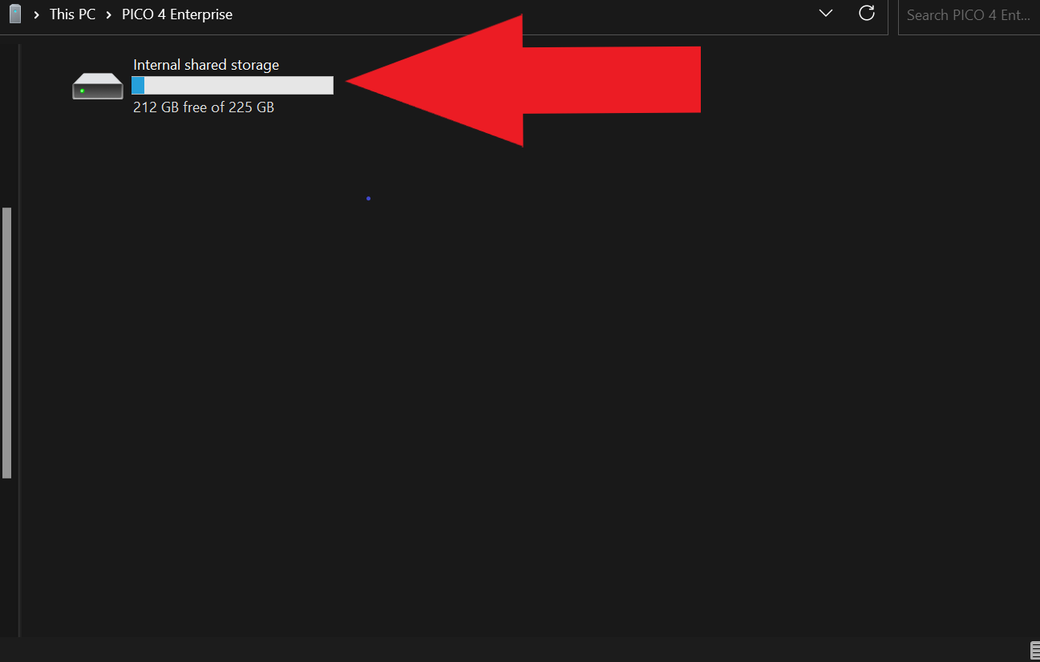
4. From here navigate to the android folder.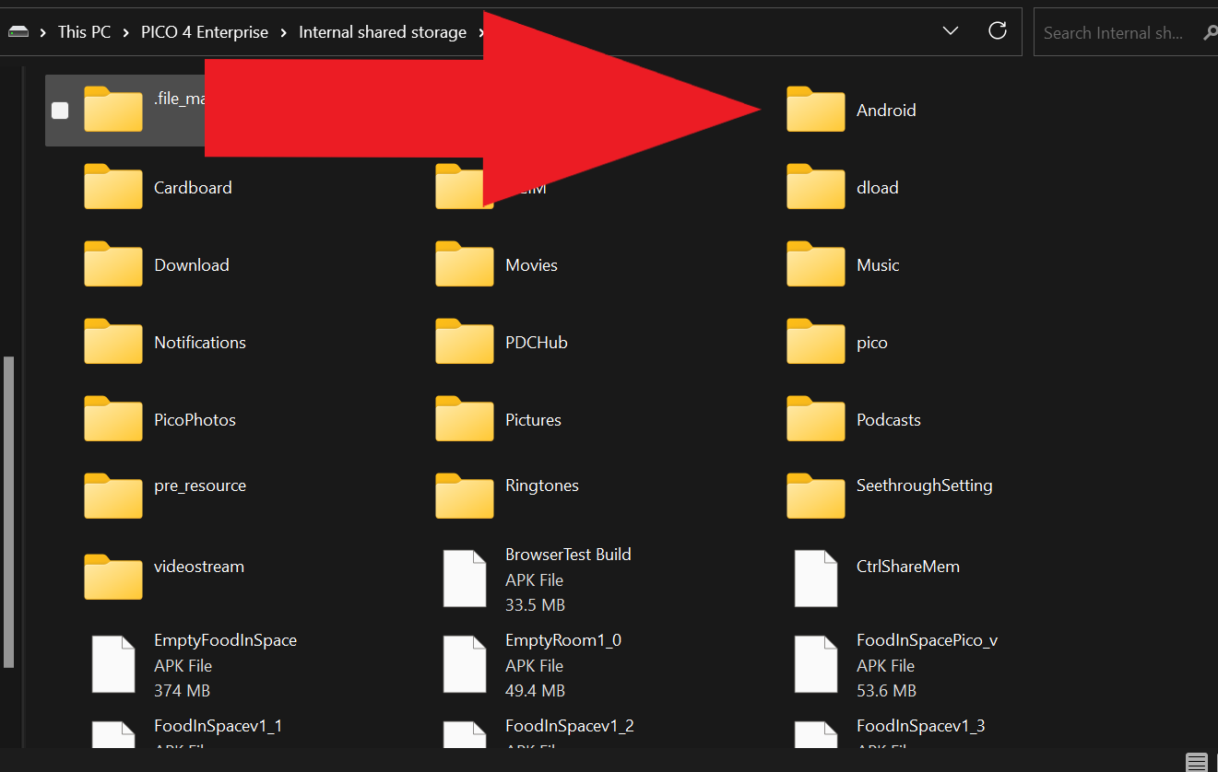
5. Then navigate to the data folder.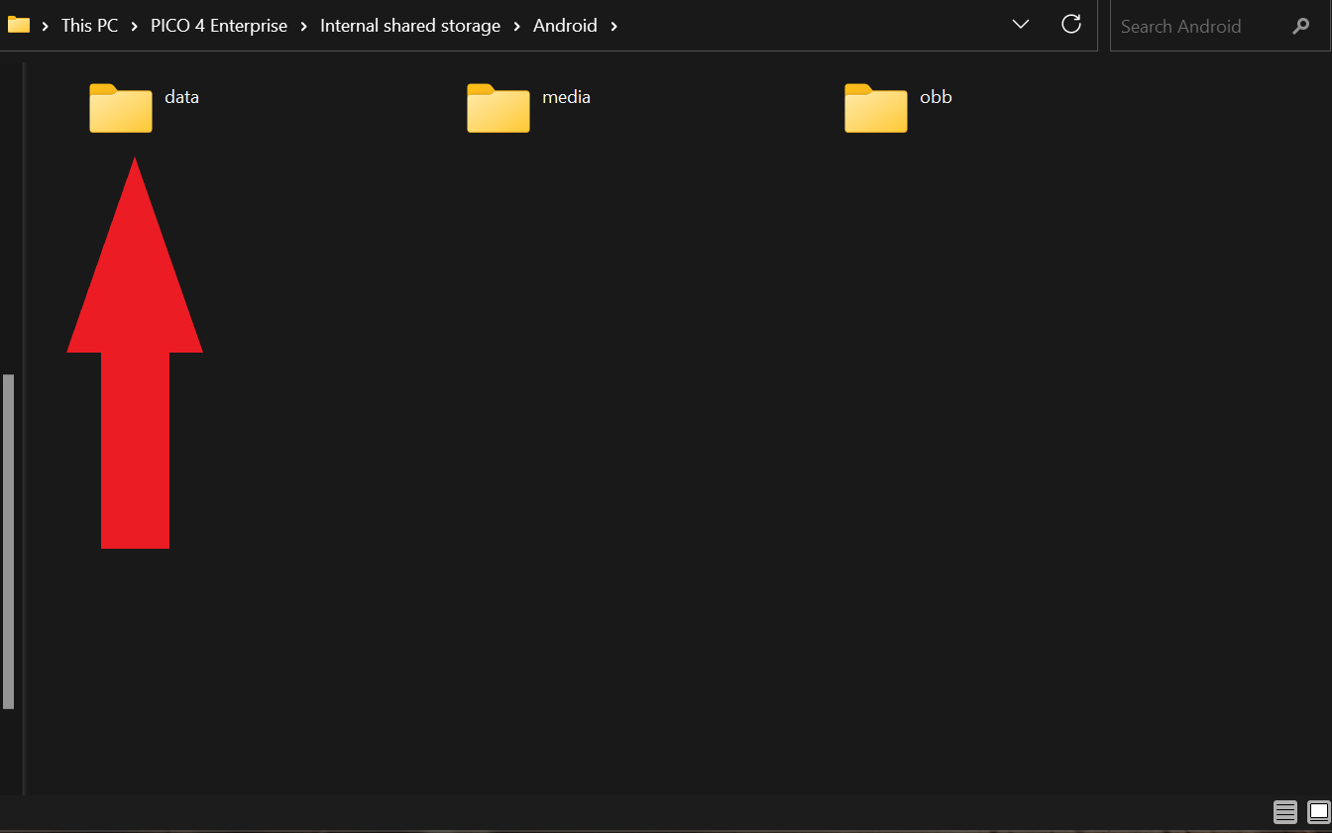
6. Then navigate into the app data file called com.FoodInSpaceInc.FoodInSpace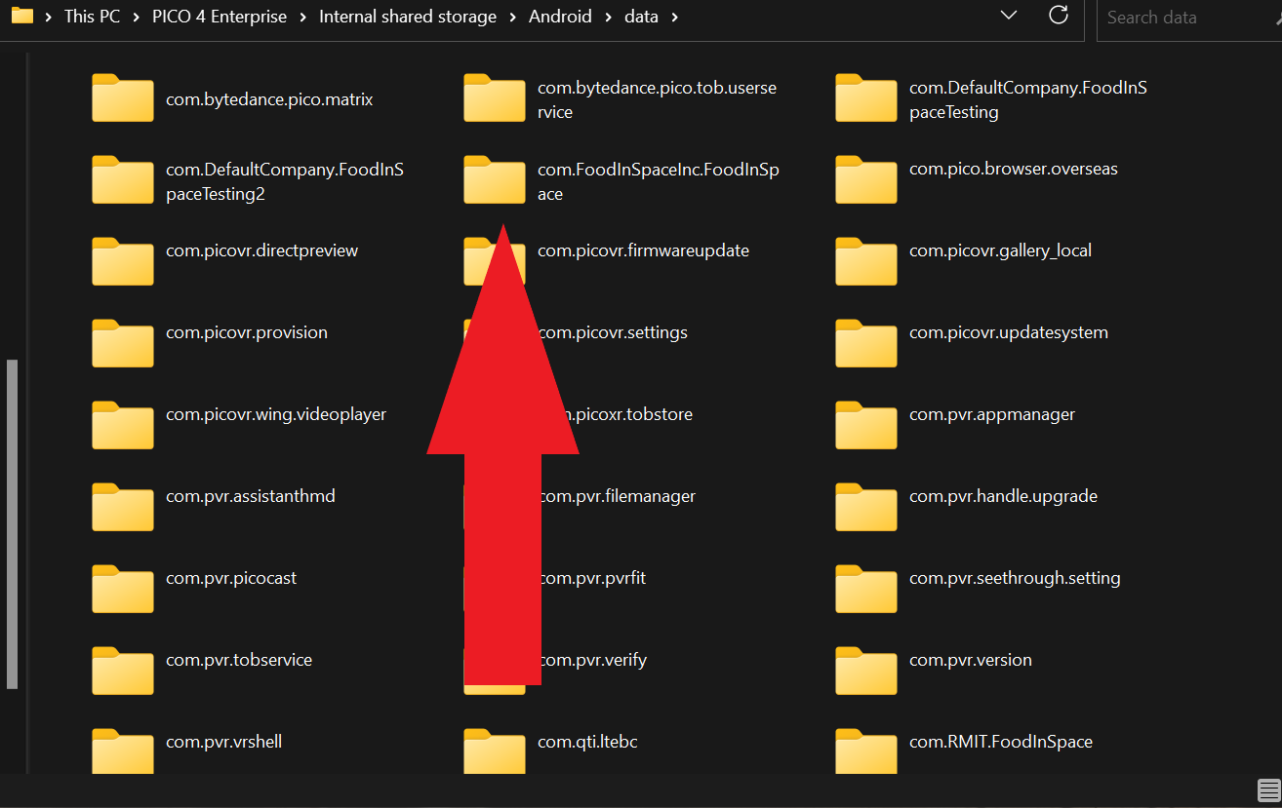
7. Then Navigate into the files folder.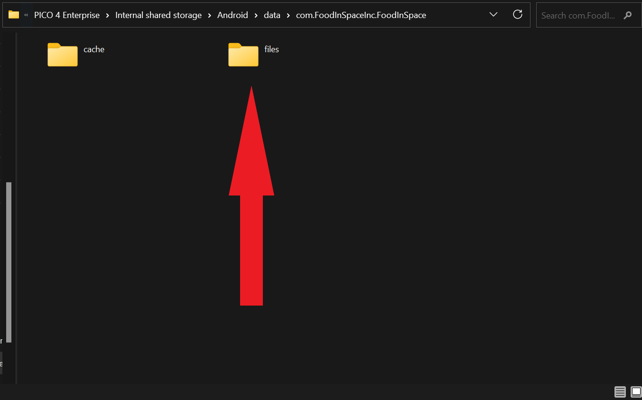
8. From here select the Survey URL text file.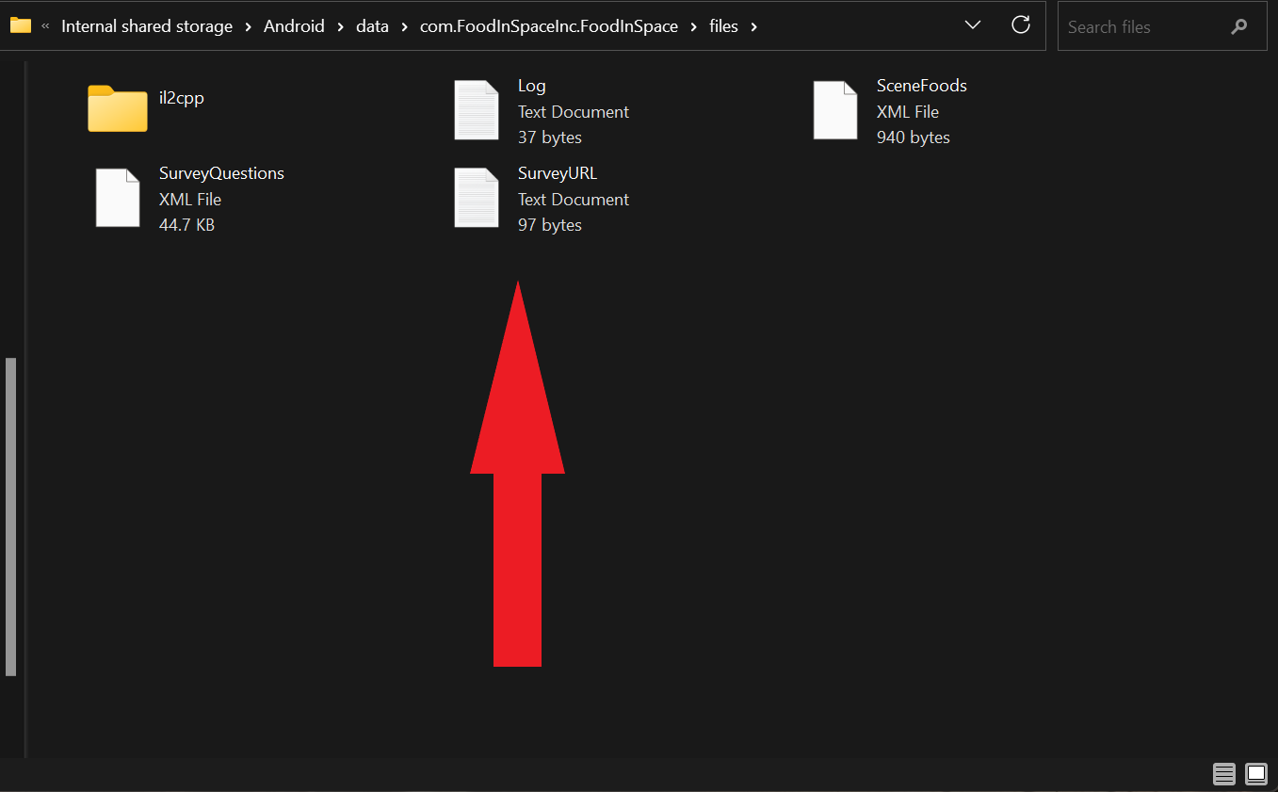
9. The path should look like this:  
   PICO 4 Enterprise/Internal shared storage/Android/data/com.FoodInSpaceInc.FoodInSpace/files/SurveyURL
10. The top URL is for the survey you wish to use.
11. Get the URL for the survey you want to use and replace the first URL in the list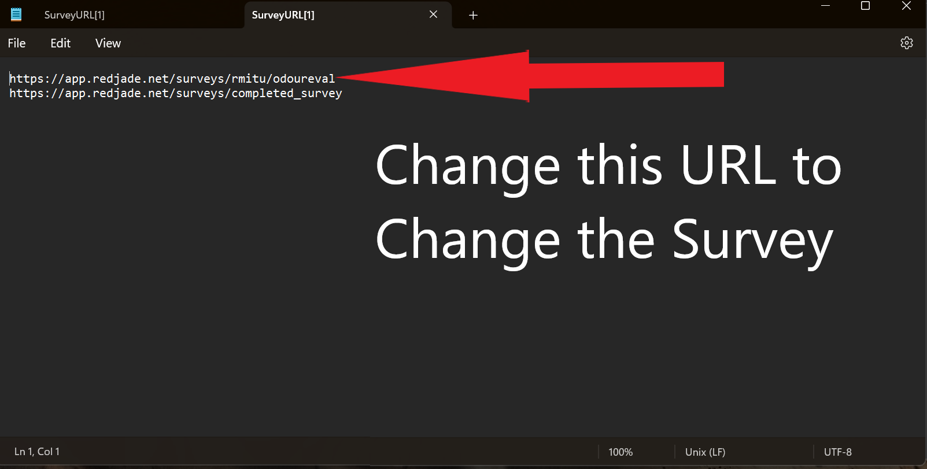

This will change the survey for the non-tutorial survey in the food and space application

The Second URL here is for the page on which you want the Survey to close in the application.

Currently it is using a URL that appears after a survey completes. If you want the Survey to close on a different page change this URL as well. 